“Back to the Bay”
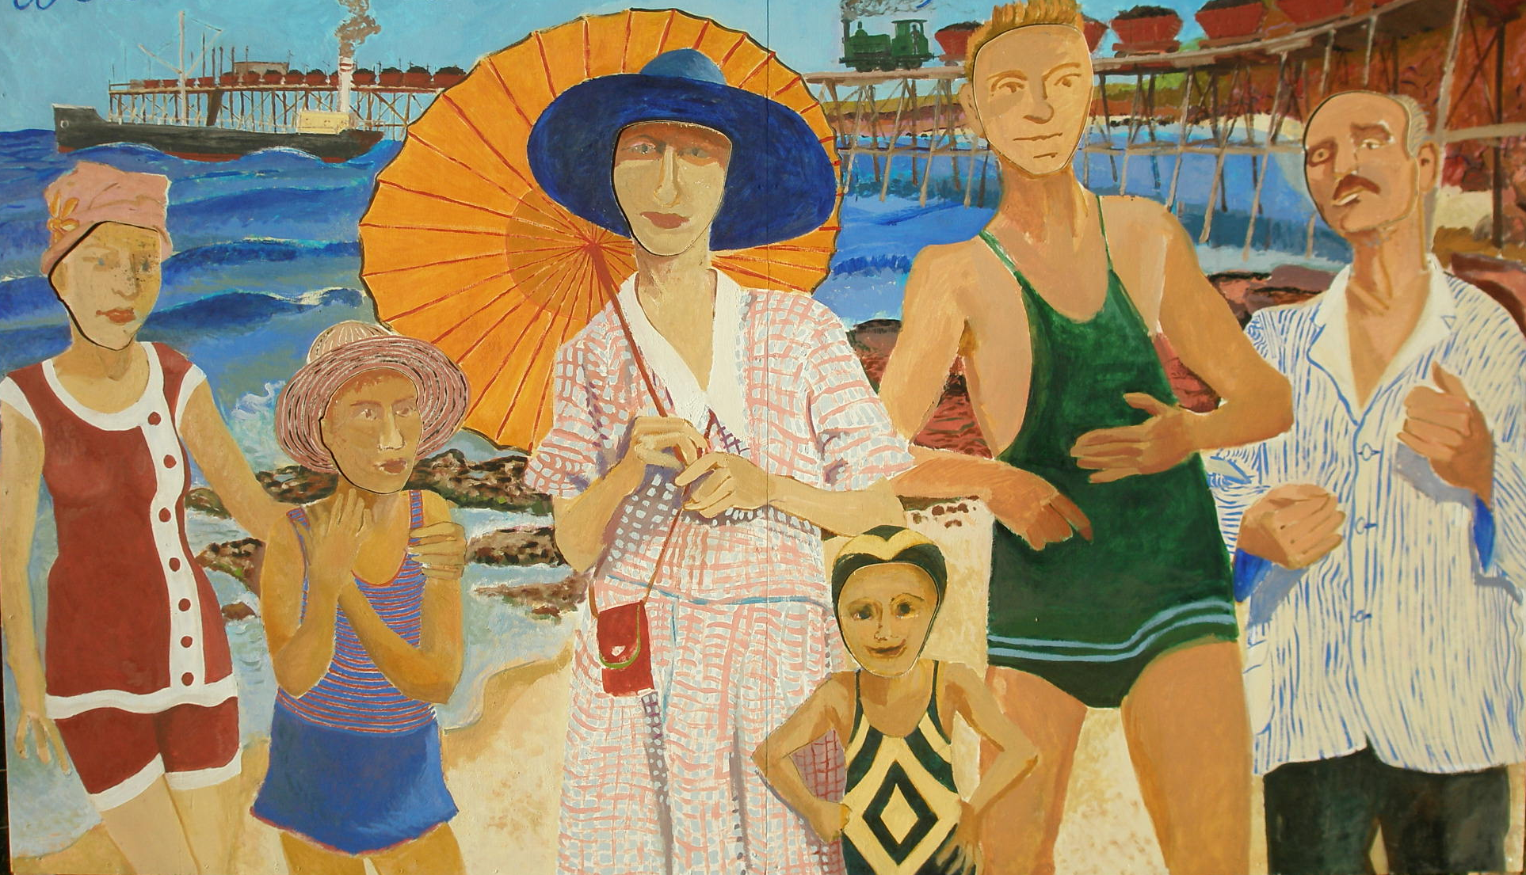
  Celebrating the heritage of
Catherine Hill Bay 
Saturday and Sunday, 5th& 6th October 2013, 10am-4pm

“Back to the Bay” Cultural and Heritage Festival

Featuring: Bands at the Pub; Film Night; Art Show; Mufti Bowling at the Bowlo; stalls; heritage walks; heritage exhibition; access to the gardens of the Bay School where ‘celebrity gardener’ Linnie Ross (2GB Gardening Show )will be giving garden talks; great food and wine.

We are currently Calling for Stall Holders (Artisan, Antiques, Collectables, Food Vendors). Visual Artists to participate in the event.
Anyone willing to set up a cake stall or local produce stall would be most welcome.

Contact: Sue Whyte, 49762310; suewhyte80@bigpond.com

