Catherine Hill Bay Progress Association and Dune Care Incorporated
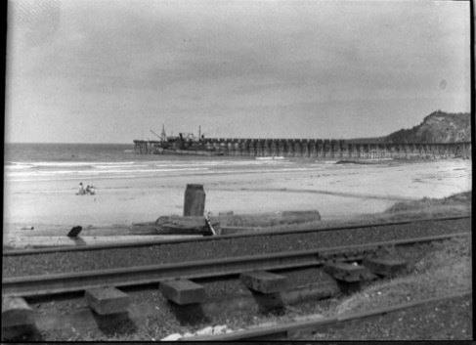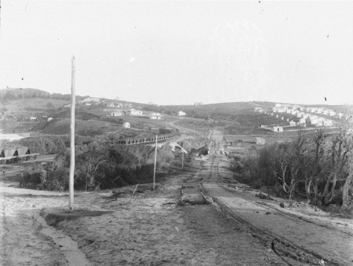
Annual Membership Form
Membership Category A: $20.00pa* $10 pensioners |  | Cultural Precinct Residents
Name 1: | Residential Address: | E-mail Address: | Phone: | Years paid:
Name 2: | Residential Address: | E-mail Address: | Phone: | Years paid:
Name 3: | Residential Address: | E-mail Address: | Phone: | Years paid:
Name 4: | Residential Address: | E-mail Address: | Phone: | Years paid:
Name 5: | Residential Address: | E-mail Address: | Phone: | Years paid:
Membership Category B: $20.00pa |  | Friends of Catherine Hill Bay
Name 1: | Residential Address: | E-mail Address: | Phone: | Years paid:
Name 2: | Residential Address: | E-mail Address: | Phone: | Years paid:
Donation amount: $ |  | Total amount paid: $
EFT: for electronic funds transfer, please write your family name in the “recipient’s details” section of your bank’s transfer form

- Your membership is an investment in protecting and retaining the unique heritage (Cultural Precinct) and environment of Catherine Hill Bay; Donations are gratefully accepted to continue our good work
- See our Constitution (via our website) for a full description of the Association’s governance and membership arrangements
- Category A membership requires that the person is a property owner in the Catherine Hill Bay Cultural Precinct, or who is a current resident of the Precinct who is not a property owner but has resided for longer than three months; The Association’s Constitution provides for natural persons only to be members; Accordingly, incorporated entities and their officers cannot be members unless they meet the residency requirement; The Association assesses each application for membership and will advise you in ninety (90) days if your application has not been accepted; Annual membership is on a financial year basis
- Annual Membership Fees: Cultural Precinct Residents $20.00 per person per year; Friends of Catherine Hill Bay $20.00 per person per year; $10.00 for pensioners/concession card holders for both categories; Payment membership fees in advance can also be accepted, please indicate the number of years membership being requested in the above table
- Please email completed forms to accounts@catherinehillbay.org.au
- Electronic Payments: Commonwealth Bank (Swansea Branch); BSB 062 820; Account No: 10237595; Please provide your name(s) in the transfer; Please send completed forms electronically to the Association, or via mail to CHB Progress Association, PO Box 72, Swansea NSW 2281; Electronic receipts will be issued to members
- Progress Association Contact: President Sue Whyte; e-mail: suewhyte80@bigpond.com; mobile: 0409 344 253

