

ALP donor projects scuttled

MATTHEW MOORE AND LINTON BESSER
September 1, 2009
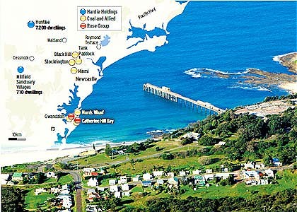
An aerial view of Catherine Hill Bay. Photo: Peter Stroop
THE state's biggest housing development and a host of other Hunter Valley projects backed by Labor Party donors are facing collapse after a court ruled illegal the agreements negotiated secretly to have them approved.
A crushing judgment in the Land and Environment Court has swept away plans by Rose Group to build 600 houses at the coastal hamlet of Catherine Hill Bay, south of Newcastle, and another 187 houses at nearby Gwandalan on Lake Macquarie, and sounded the death knell for developments at both sites planned by Coal & Allied.
While Justice David Lloyd's judgment only applies directly to those two sites, it will almost certainly unravel all development approvals involving memoranda of understanding and deeds of agreement with land swaps - where developers win approval in exchange for handing privately owned conservation land to the Government.
As revealed in the Herald before the hearings, the Government's own legal advice predicted it would lose the case, warning all similar deals were at risk.
The chief executive of the Urban Development Institute of Australia, Stephen Albin, said ''this outcome does nothing to help the state's already fragile reputation as a sound and certain place for urban investment''.
Rose Group, which has lost its development approval, condemned the decision. It said it ''has thrown a pervasive cloak of uncertainty'' over the future of Catherine Hill Bay, but had not decided whether it would appeal.
While environment and planning officials had hailed land swaps as a great way to expand conservation lands, Justice Lloyd called them a ''land bribe''.
The former planning minister Frank Sartor signed the agreements with Rose Group, while the woman who replaced him last September, Kristina Keneally, signed the deed with Hardie Holdings. This was part of a deal to build the biggest housing project in the state, 7200 houses at Huntlee near Branxton.
The Land and Environment Court is likely to pull the rug from under that project in October when it hears an appeal lodged by activists citing identical grounds to those upheld yesterday.
With the Hunter Valley due to house an extra 160,000 people by 2031, the Government has been using these deeds with developers to provide agreements for a host of new housing estates.
Separate memorandums of understanding have been signed with Hardie Holdings for Sanctuary Villages, near Cessnock, and with Coal & Allied for Catherine Hill Bay and Gwandalan, and nearby sites at Minmi, Link Road, North and South Stockrington and Black Hill.
The court has rejected this process because an ordinary person might think the minister was biased when approving projects already given the nod through an agreement for a land swap.
''What reason was there for the minister to make the commitments that he did if they did not have significance in the decision-making process and could not be expected to influence the minister's exercise of his powers?'' the judge said.
The president of the Catherine Hill Bay Progress Association, Sue Whyte, was ''ecstatic'' but said Ms Keneally must revoke the rezoning of conservation lands to stop Rose Group from making a new development application.
Ms Keneally promised the Government would not appeal the decision or attempt to validate the deeds with retrospective legislation. But she would not commit to revoking the rezoning.
''Because the court identified that the MOU and deed were invalid we need to look at how far back in the planning process we need to go in order to redetermine or to determine anew or determine for the first time these applications,'' she said.
Mr Sartor said the decision was ''perplexing, particularly because the judge found bias in deciding the development applications, but no bias in rezoning the land which still stands''.

