Bay braces for battle

By LEESA McKENNY
The Newcastle and Lake Macquarie Post
Wednesday, February 7, 2007
Page: 1

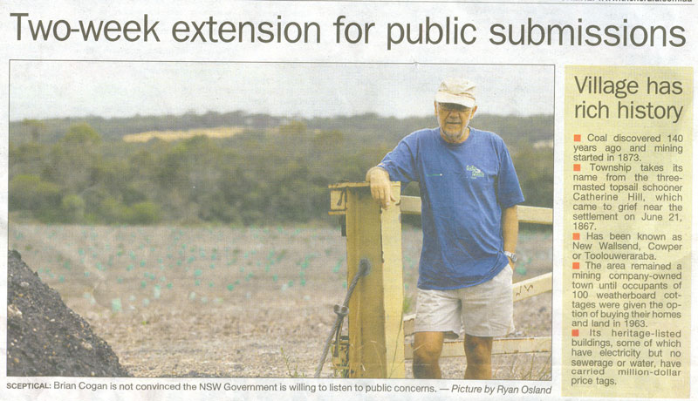
SCEPTICAL: Brian Cogan is not convinced the NSW Government is willing to listen to public concerns – Picture by Ryan Osland

Village has rich history
■ Coal discovered 140 years ago and mining started in 1873.
■ Township takes its name from the three-masted topsail schooner Catherine Hill, which came to grief near the settlement on June 21, 1867.
■ Has been known as New Wallsend, Cowper or Toolouweraraba.
■ The area remained a mining company-owned town until occupants of 100 weatherboard cottages were given the option of buying their homes and land in 1963.
■ Its heritage-listed buildings, some of which have electricity but no sewerage or water, have carried million-dollar price tags.

CRITICS of the proposed 600-dwelling development at Catherine Hill By now have until March 2 to lodge a submission to the NSW Department of Planning.

Planning Minister Frank Sartor said the two-week extension for submissions was a direct response to requests from the community.
“Any interested groups or individuals are encouraged to read the proposals and have their say.” he said.

Under a memorandum of understanding with the government, Sydney developer Rosecorp hopes to develop up to 60 hectares of land at the former Moonee Colliery and dedicate 310 hectares for environmental conservation.

Catherine Hill Bay Progress Association secretary Brian Cogan said the group sought the extension ”in very strong terms” from the department because it felt information about the plan was not getting out to the community.

“[The concept plan] wasn’t on display at Catherine Hill Bay and Gwandalan, which is an extraordinary oversight” Mr Cogan said.

That was rejected by the minister’s spokeswoman, who said the department had made the copies of the plan available to the public from January 3.

It had gone to great lengths to ensure residents had time to read the initial plans and lodge submissions, such as posting copies to some residents, she said.

Many residents fear that if the Rosecorp plan goes ahead, in addition to a plan for 300 dwellings on 50 hectares at Catherine Hill Bay under a similar deal with mining company Coal & Allied, the heritage values of the 100-dwelling town will fall.

Rosecorp managing director Bryan Rose has said the proposed development would be consistent with the heritage characteristics of the area.

Mr Cogan was not convinced the government was serious about addressing public concerns.

“People feel as if the government has just walked over them and they’re angry,” he said.

Mr Sartor announced in December he would seek advice from an independent panel appointed to review the development at Catherine Hill Bay, as well as that at nearby Gwandalan, once the March deadline has passed.

Mr Cogan said his group had 27,000 hits on its website in January alone.

“There’s a huge momentum of protest building”, he said. “The village is being artificially expanded to 1000 houses in one fell swoop. We are by no means opposed to controlled development at Catherine Hill Bay, but the proposed developments are too big and overwhelming.”

To view the plans, go to www.planning.nsw.gov.au

