Catherine Hill Bay keen for heritage listing

BY MATTHEW KELLY
3/01/2009 4:00:00 AM
CATHERINE Hill Bay residents are hopeful their village will be added to the state heritage register in the near future.
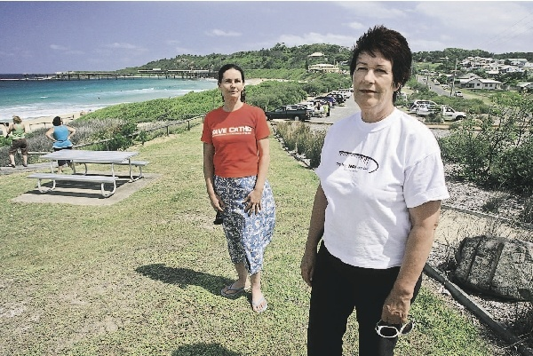
CONFIDENT: Progress association member Ireen Wong, left, and president Sue Whyte yesterday. - Picture by Brock Perks
The listing would strengthen the community's campaign against large-scale development in the area, such as that proposed by Rose Group and Coal & Allied.
It would also give added protection to existing elements of the built environment, such as old mining cottages and the coal jetty.
The listing would be made by NSW Planning Minister Kristina Keneally on the recommendation of the NSW Heritage Commission.
Catherine Hill Bay Progress Association president Sue Whyte said she had been given a verbal assurance by former planning minister Frank Sartor that the title would be granted.
"We are confident we will get it," she said.
"This is something that the people of Catherine Hill Bay really need.
"It would mean that any new development would not be allowed to degrade the heritage values of the area."
Rose Group and Coal & Allied could not be contacted for comment about the proposed heritage listing yesterday.
The National Trust is also pushing for Catherine Hill Bay to be listed on the national heritage register.
Federal Environment Minister Peter Garrett said late last year that he would not use his emergency powers to assist in listing the village on the national register.
The Environmental Defenders Office has launched court action to stop Rose Group's proposed developments at Catherine Hill Bay and nearby Gwandalan.
The group is seeking to overturn the approvals made last year by Mr Sartor under 3A of the state's planning laws.
Mr Sartor's approval also resulted in the Surfrider Foundation withdrawing its support for Catherine Hill Bay to become a national surfing reserve.

