

Catherine Hill Bay will be swamped by McMansions, say residents

Matthew Moore
August 16, 2011
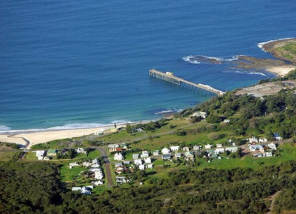
Battleground ... Catherine Hill Bay. Photo: Peter Stoop
RESIDENTS from the heritage-listed town of Catherine Hill Bay have launched a last-ditch legal action to stop a subdivision they fear will allow construction of 600 houses with no controls over what they will look like.
In the Land and Environment Court the residents have sought an injunction to stop the developer Rose Group from subdividing the land at Catherine Hill Bay, south of Newcastle, and launched proceedings to overturn a decision by the Planning Assessment Commission in May approving the subdivision.
The president of the Catherine Hill Bay Progress Association, Sue Whyte, said the legal action was probably the last chance to stop the development.
Advertisement: Story continues below
The former planning minister Tony Kelly was to decide the Catherine Hill Bay subdivision himself but passed it to the commission four days before the March 26 election.
Rose Group's application to rezone its land for housing has been vigorously opposed by Lake Macquarie City Council and by residents who wrote many of more than 3500 submissions complaining it would destroy the heritage value of the old coalmining hamlet.
Rose Group had originally proposed to develop the land itself but after residents stopped it in an earlier court case, it applied to simply subdivide the land and sell the lots.
While the PAC approved the subdivision, it rejected an accompanying development control plan to determine the shape and size of the housing, which it said had many shortcomings and must be ''substantially enhanced''.
Kirsty Ruddock, a lawyer with the Environmental Defenders Office, which is running the case, said the lack of protection for heritage values in the subdivision would be the basis of the challenge.
''The main focus will be on the fact the PAC has approved the request for the project approval for the subdivision for 600 houses but they rejected the development control plan that was provided by the developer.''
With no development control plan, landowners will be free to build any house that fit within the definition of ''complying development'' policies, which were enacted several years ago to allow people to build houses without lodging plans with the council.
Ms Whyte feared Catherine Hill Bay would be swamped with McMansions.
Bryan Rose, from Rose Group, said he had not yet received details of the claim.
The Minister for Planning, Brad Hazzard, could not be contacted.

