Top of Form


Catho housing approval raises ire of Lake Mayor
Posted May 20, 2011 08:27:00
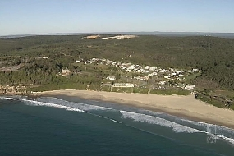
Hundreds of new homes approved for the heritage-listed village of Catherine Hill Bay. (7pm TV News NSW)
Lake Macquarie Mayor, Greg Piper says the Planning Assessment Commission's approval of a housing development at Catherine Hill Bay is proof the decision should have been in Council's hands.
The Rose Group's proposal for 560 new homes was approved despite substantial changes being ordered and a draft Development Control Plan being deemed inadequate.
Councillor Piper says the assessment should have been given to Council after a controversial land swap deal with the State Government saw the original plans thrown out.
He says he is disappointed the Commission did not follow the Council's advice.
"I would have thought that the Planning and Assessment Commission would have placed a higher weighting on Council's opinion relating to these issues," he said.
"And whilst I know that we were given a hearing, they obviously didn't accept our position on that and that's very disappointing."

