Catho residents slam "disastrous" decision
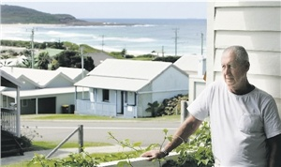
DISASTROUS: Wayne Grainger reflects yesterday at his house in Catherine Hill Bay.- Picture by Peter Stoop

BY DAMON CRONSHAW
28/02/2009 4:00:00 AM

CATHERINE Hill Bay residents said they were disappointed but not surprised by federal Environment Minister Peter Garrett's decision to approve the Rose Group's development in their suburb.
Resident Wayne Grainger, who has lived in the town for 27 years, said Mr Garrett's decision was "disastrous" for the town.
"The Rose development, combined with the Coal & Allied development that hasn't been approved yet but probably will be, means this small village will be surrounded by 1000 houses," Mr Grainger said.
"The character and heritage values of the place will be lost."
Mr Grainger said residents had hoped Mr Garrett would have at least reduced the size of the Rose plan.
"We've always said there was room for some development around here, but the scale of the Rose and Coal & Allied plans are over the top," he said.
Resident Bill Plumridge, who has lived in the Bay for most of his 62 years, said he was not surprised Mr Garrett had given approval.
"We're still not happy about it, we think it is an overdevelopment," Mr Plumridge said.
"Some people had the feeling he [Mr Garrett] was quite supportive, but realistically I don't think we had a chance.
"I don't know there's much more we can do, we've just about exhausted our chances."
Residents have appealed in the Land and Environment Court against the NSW Government's decision to approve the Rose plan.
The approval fell under the controversial part 3A planning laws, which limit the right to appeal development decisions.
Residents will ask the court to rule on whether the planning process was followed correctly.
If the court was not satisfied with the process, the Government could ask for it to be redone.

