

Greens take allegations to ICAC
Debra Jopson and Edmund Tadros
May 5, 2008
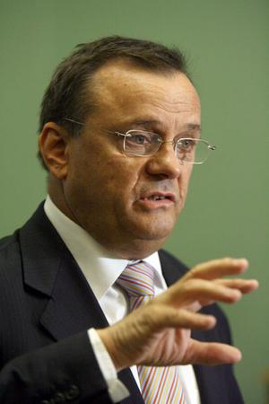
Under fire ... Minister for Planning Frank Sartor says he is not aware of who does and does not donate to the party.
Photo: Simon Alekna
THIRTEEN development com-panies that have succeeded in getting the State Government to take over and approve $3 billion worth of their projects in three years have, between them, donated millions of dollars to Labor in that time, NSW Greens research has found.
On the other hand, the Minister for Planning, Frank Sartor, rejected 28 projects submitted for approval under part 3a of the Environmental Planning and Assessment Act by development companies that made no political donations, the Greens say in a dossier they plan to give to the state's corruption watchdog today.
On behalf of the Greens, the MP Sylvia Hale is calling on the Independent Commission Against Corruption to investigate donations from property developers to political parties and candidates, alleging that it "represents a systemic corruption of the planning system in NSW".
The Greens will cite 12 "heads of evidence", including their analysis of outcomes of development applications that Mr Sartor has designated major projects, making himself the consent authority. The Greens say their research shows political donors receive favourable treatment over non-donors.
There is also evidence that on many occasions, companies whose development applications Mr Sartor was considering had made "numerous large donations" to the NSW ALP while he was considering their application, Ms Hale says in her letter to ICAC.
A spokeswoman for Mr Sartor said: "This wouldn't be the first time the Greens have made false claims, and probably won't be the last." The dossier shows time lines for nine companies' donations to Labor that were made before their projects were designated for part 3a approval and while they were undergoing the approval process.
They include Payce Consolidated, a staunch Liberal donor for five years, which made its first Labor donation in June 2006, one month before it sought a part 3a approval for its $251 million Homebush Bay residential development. It donated $105,000 to state Labor between applying and obtaining approval.
One month after Buildev Tinonee applied for part 3a approval for its Bucketts Way rural residential development in December 2005, four Buildev companies began regular donations to the NSW ALP totalling $9164 monthly, which continued at least until April last year.
Multiplex donated $33,000 two months after the State Government called in its Civic Plaza development for Sydney Water Corporation, while Meriton Apartments donated $50,000 seven months before applying for major project status for its $45 million Rhodes development. In August 2006, it donated another $100,000 to Labor, with another $5000 in March last year, three months before winning approval.
Rosecorp Pty Ltd donated $143,600 while seeking State Government approval for its projects at Breakfast Point in Sydney and Catherine Hill Bay south of Newcastle.
Mr Sartor's spokeswoman said development proposals for Catherine Hill Bay had been subjected to one of the state's most transparent and publicly accessible planning processes.
The planning minister became the consent authority for Rhodes peninsula developments before Mr Sartor became minister, she said, and a number of his decisions had been appealed by dissatisfied developers.
Ms Hale conceded in her letter that ICAC had already declined to investigate some of the matters on the grounds that there was a legal regime for the receipt of political donations and that the planning minister was not required to declare political donations when making part 3a approvals. The commission had previously considered potential corruption risks arising from the exercise of ministerial discretion for these approvals.
But she was raising new matters and ICAC's recommendations when it examined corruption risks in the process had not been implemented, she said.
Mr Sartor's spokeswoman said: "Proposals are determined strictly on their merits, following advice from the Department of Planning, which is an independent civil service …
"We have no idea how donors or non-donors to the party are treated because, as donations are not a relevant planning consideration, the minister is unaware of who does and doesn't donate to the party."

