

Huge land deals 'illegal'
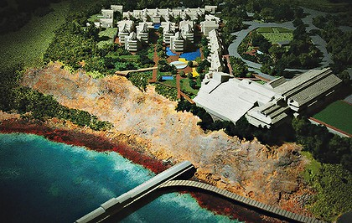
A model of the Catherine Bay development. Photo: Peter Stoop

Linton Besser and Matthew Moore
June 9, 2009
MULTIBILLION-DOLLAR land deals the State Government signed with two big Labor Party donors are likely to be ruled illegal by the Land and Environment Court, secret advice to the Planning Minister, Kristina Keneally, says.
Government lawyers have proposed rushing retrospective legislation through Parliament next week to validate the contracts and guarantee seven big developments and 12,000 hectares of parkland in the Hunter Valley.
The developers involved in the deals, Duncan Hardie and Bob Rose, made unrelated donations of more than $318,000 through various companies to the NSW Labor Party in the four years before the 2007 election.
Ms Keneally has been told she is likely to lose a court case that begins today over the massive redevelopment of Catherine Hill Bay and Gwandalan, backed by Mr Rose (as well as a subsequent challenge over Mr Hardie's 7200-home Huntlee development at Branxton).
Defeat in the case could unwind the Government's environmental land offset scheme, under which almost 8000 hectares of privately owned bushland is pledged for transfer to national parks and conservation zones.
Despite sustained protests by locals, the Government approved 787 new homes at Catherine Hill Bay last September, increasing by 10-fold the beachside hamlet's population.
In the Land and Environment Court today, the Gwandalan-Summerland Point Action Group will allege that the former planning minister Frank Sartor was influenced by "irrelevant" material when he approved the development. This is because he and the former environment minister Bob Debus had previously signed a deed with Mr Rose's companies that swapped Government approval of the project for 300 hectares of bushland owned by Mr Rose that would then be declared a conservation area.
A top-level legal opinion, written by the barristers John Griffiths, SC, and Stephen Free, and obtained by the Herald, warns that the deed was never envisaged by the planning laws and could be declared invalid. In relation to a crucial legal point that the Government must win, the advice says "we consider the minister has limited prospects of success". "In particular, we think there is a significant risk that the court might find that the minister was not permitted to have regard to the deed, in circumstances where the deed did not comply with the planning agreement provisions set out in the act and the regulations.
"Further, although it is not certain, we think there is a real prospect that the court could find that the deed itself is invalid."
The problem extends to one of the biggest developments in the state, Huntlee, which was rezoned by Ms Keneally on January 9. The 2340-hectare site and a smaller development - Sanctuary Villages, near Paxton - owned in part by Mr Hardie's companies, were subject to a similar deed that Mr Sartor signed in December 2006. The Government's approval of 2300 homes in the $1.8 billion Huntlee development is also under challenge.
Meanwhile, the Planning Department is finalising deeds covering four other large residential and employment developments in the Hunter Valley, all of which will be invalid if the Government loses this week's case.
The advice prepared for Ms Keneally's office suggests retrospective "validating legislation" may be needed to protect the two land-swap deals. "The earliest time frame for validating legislation is if a minute is drafted and approved by cabinet by 15 June 2009 for introduction into Parliament that week," it says. "This would be after the hearing (but presumably before judgment) and costs of the litigation are likely to be awarded against the minister in those circumstances."
As for the other Hunter sites yet to be finalised, the advice says the Government should draft proper planning agreements, which require a period of public consultation, unlike the privately negotiated deeds of agreement.
Ms Keneally said: "I will not comment on a case before the courts."

