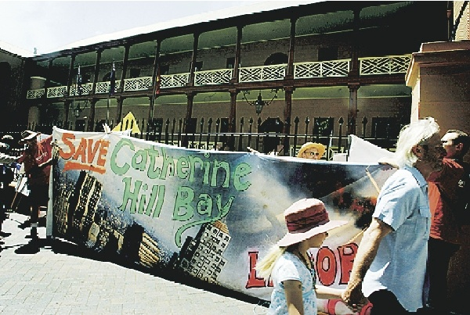
ANGRY: Protesters gather at Hyde Park yesterday. - Picture by James Alcock

Protesters rally to save Catho
The Herald
BY MELISSA LYONS
20/10/2008 9:25:00 AM

HUNTER residents joined hundreds of people in Sydney yesterday to protest against state planning laws which they say allow uncontrolled development.
Catherine Hill Bay Progress Association president Sue Whyte took part in the Hyde Park rally to call for protection against development on sites from the Hunter Region to the North Coast.
Carrying banners and donning shirts that read "Save Catho", the protesters want to scrap Part 3A of the state's planning legislation.
The law gives the Planning Minister power to take over significant developments, including the 600-house development at the bay.
"It really became very, very clear that the people of Catherine Hill Bay are saying enough is enough. We're not going to put up with it anymore," Ms Whyte said.
Representatives from Trinity Point, Morisset, Stroud and Newcastle also showed their support.
"If we don't turn this around in the next month it's the end for Catherine Hill Bay," Ms Whyte said.
Nords Wharf residents' spokesman Kevin Fitzgerald said the laws needed to be abolished to secure the future of small communities.
Opposition planning spokesman Brad Hazzard offered some hope, telling the crowd a Liberal government would abolish the legislation.
"From Morisset to Mudgee from Currawong to Catherine Hill Bay, this Government is going to hear a very loud message and that is, we have had it with your planning laws," Mr Hazzard said.
"The state Liberal and National parties are absolutely over this rotten dollars for deals approach to planning."
Mr Fitzgerald welcomed the call, but questioned the Opposition's motives.
"I think it may have been a political brownie-point call," he said.
Environment advocate Liz Claridge, from Broke, said yesterday's rally was important to send a clear message to the State Government.
"They've got to gain the trust of the people . . . there is no trust, you can see here," she said. with AAP

