

Sartor to ignore his own panel
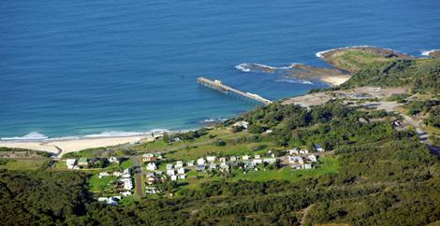
Catherine Hill Bay.
Photo: Peter Stoop
Wendy Frew Urban Affairs Editor
July 2, 2008
THE State Government is expected to approve within days a controversial project to build luxury homes on the headland at Catherine Hill Bay, even though an independent panel has recommended significant modifications before approval.
A final decision about the 600-apartment development in the small coastal town 100 kilometres north of Sydney has not been made, said the Planning Minister, Frank Sartor, who told the Herald he had not seen his department's final advice, based on the panel report.
But local residents opposed to the Rosecorp proposal said Mr Sartor told them about a month ago the developer would probably be given permission to incorporate into the development an old coal mining storage structure, or bin building, on the headland, and build some homes to two storeys, despite recommendations against both of those features.
Mr Sartor told the Herald he could not "be specific" about the proposal because he had not read the Planning Department's report, but he was due to meet some residents again yesterday.
An independent assessment of Rosecorp's proposal recommended a one-storey limit on detached dwellings in one of the new hamlets and said the developer should not be able to adapt the bin building into its apartment design.
Residents and others keen to protect the town from overdevelopment have waged a long battle against two proposals that, together, would increase the number of homes in Catherine Hill tenfold. The town is on the Wallarah Peninsula, which sits between Lake Macquarie and the Pacific.
The independent panel, appointed by Mr Sartor and chaired by Gabrielle Kibble, recommended that the bin building, built in the 1960s to drop coal down to the nearby jetty, be reused only as a public lookout or low-intensity cafe.

