

Tell 'em they're dreaming - north shore gets bolshie
September 28, 2009
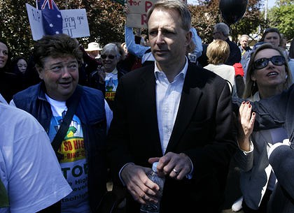
Paul Fletcher was heckled. Jonathan Coleman, left, was not. Photo: Dean Sewell
Politicians have been accused of 'hijacking' a people's protest, writes John Huxley.
IT WAS billed as a state funeral to mark the Death of Democracy, slain by NSW government planners who were ignoring residents, taking money from developers, turning pleasant communities into high-rise concrete jungles.
But even before the hearse containing the coffin had started its slow procession down the Pacific Highway to Parliament House yesterday, the event was beginning to look like a movie called Four Politicians and a Funeral.
They may have been mild-mannered, mainly middle-class, middle Australians, but they were angry. Very angry, about the lack of consultation, the loss of local decision-making, the ''Las Vegas-isation'' of sleepy suburbs such as those in Ku-ring-gai.
Angry ''mourners'', mustering in a supermarket car park at Turramurra, turned on the former federal Liberal leader Brendan Nelson and Paul Fletcher, the man anointed to succeed him in the safe seat of Bradfield.
''You're trying to hijack this event,'' an organiser, Chris Drummer, shouted at Dr Nelson as he lectured the media about unhearing ministers, unsympathetic dog-box developments and environmental vandalism.
''This is about the people, not politicians,'' warned Jonathan Coleman, one of a strong contingent of celebrities including Wendy Harmer, Richard Clapton, Michael Caton and Catriona Rowntree.
When the procession, led by a lone piper playing Amazing Grace, reached Parliament House, the Opposition Leader, Barry O'Farrell, kept his distance and, temporarily, his counsel. Perhaps he had been warned.
Clearly, the Planning Minister, Kristina Keneally, had been told what to expect. The only politician to have been invited to the protest, she was a no-show. It was just as well.
From Balmain and Beecroft, Catherine Hill Bay and Ku-ring-gai, Dungog and Double Bay, from all parts of the state, the people had come to unload on its unloved government. To put its next government on notice.
They carried black balloons. They waved placards with slogans ranging from the reasonable, such as ''Ku-ring-gai today, your suburb tomorrow'', to the reckless, such as ''Land rights, not 3rd Reich'', ''Zimbabwe, Burma, NSW.''
They cheered as one speaker after another slammed recent planning decisions.
Pausing only to thank the ''traditional owners, Meriton, Mirvac and Lend Lease'', Coleman related how he had returned from London and bought a house in Lindfield. It is now surrounded by three six-storey unit blocks.
Caton related how in the hit movie The Castle, his character, Darryl Kerrigan, defeated the planners and the developers, who threatened to evict his family from their home.
Not in NSW, he couldn't. Not with ministers such as Eddie Obeid and Joe Tripodi calling the shots. ''There's something rotten in the state of NSW.''
The congregation of about 1500 passed resolutions calling for local planning rights to be restored, for the hated ''Part 3A major projects'' law to be scrapped, and for an inquiry into planning decisions and developer donations.
Wreaths were then laid outside Parliament House. Activists adjourned for a wake at the nearby Leagues Club, and the undertaker Paul Notary drove his hearse back up the Pacific Highway.
Has he done protests before? ''No. Only time I've been in a protest was when I was let off school early as a 13-year-old to protest about the Vietnam War.''

