Thousands turn up to mourn “Death of Democracy”
North Shore Times
27 Sep 09 @ 03:57pm by Andrew Priestley
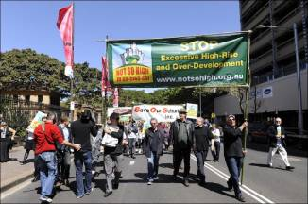
The ~Death of Democracy' procession
- 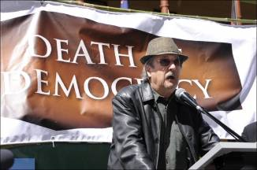
Actor Michael Caton took to the podium
- 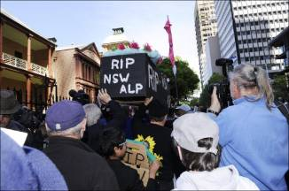
A convoy of nearly 200 North Shore residents was joined by thousands of Sydneysiders, celebrities and politicians to protest about state government planning reforms.
North Shore residents came together on Sunday at Coles carpark in Turramurra to drive behind a hearse as part of the Ku-ring-gai Residents’ Alliance protest against what they see as a loss of local voice in planning and development on the North Shore. Click here for photos.
About 160 cars drove down the Pacific Highway to Hyde Park, where demonstrators met with protest groups from across Sydney and NSW to march on Macquarie St.
Celebrity speakers including Jono Coleman, Michael Caton, Catriona Rowntree and Wendy Harmer slammed the state government for high rise developments and planning issues around the North Shore and further afield, calling for the state government’s planning reforms to be wound back and for Ku-ring-gai to be “down zoned” from current high rise zonings.
In his speech to the crowd, Jonathan Coleman attacked the state government and planning minister Kristina Keneally, who had declined to speak at the demonstration.
“The minister for planning, she’s the minister for development,’ he said.
“Who is running Kristina Keneally? Certain factions of the Labor Party are running Kristina Keneally ... and certain strings are pulled by developers ... and certain people benefit.
“It’s time the councils got their powers back and people like you got your powers back.
“We’re all being screwed, and it’s about time we screwed them.’’
Commedian and activist Rod Quantock also handed out coloured chalk for demonstrators to write messages like “Not so High”, “Get Lost Kris Keneally”, and “Developers + $ + Politicians = Corruption” on the footpath and roadway outside Parliament.
Ku-ring-gai Residents’ Alliance president Chris Drummer said the turnout at the event was beyond what he had imagined.
“It’s quite amazing. It just shows the people of Ku-ring-gai, how strongly they feel about this,’’ he said.
“It’s not just Ku-ring-gai, we have groups from around NSW.”

