

Tony Kelly's move on seaside development in Pittwater
- Nick Tabakoff
- From: The Daily Telegraph
- July 16, 2011 12:00AM
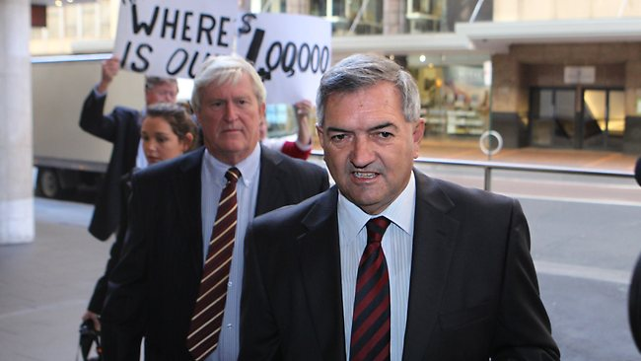
ICAC inquiry ... former planning minister Tony Kelly / Pic: Ross Schultz Source: The Australian
FRESH questions have been raised about the actions of former planning minister Tony Kelly, with revelations he acted on another huge development in the final hours of the previous state government.
On March 22, four days before the state election and with Labor in caretaker mode, Mr Kelly facilitated ultimate approval of a subdivision in heritage-listed Central Coast town Catherine Hill Bay.
He delegated the approval authority to a NSW planning body. The proposal would expand the number of houses by 600 per cent, to nearly 700.
The move shocked residents who, along with the local Lake Macquarie council, have expressed vigorous opposition.
Residents group president Sue Whyte said: "I can't believe this type of action was going on in the government's dying hours."
She said it could have dire consequences for the village, which lacks sewerage, town water and other infrastructure.
Yesterday planning minister Brad Hazzard said: "The new government is dealing with issues as they arise regarding (Mr Kelly's) decision-making, but it is not appropriate to make any further comments while ICAC is investigating."

