

Town of few set to house hundreds
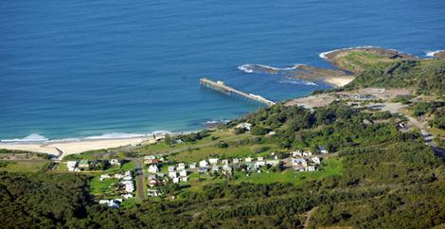
Catherine Hill Bay.
Photo: Peter Stoop

Wendy Frew Urban Affairs Editor
September 3, 2008
A CONTROVERSIAL proposal to build hundreds of luxury apartments at Catherine Hill Bay on the Central Coast will be approved by the State Government today after some final modifications were made to the developer's plans.
The Planning Minister, Frank Sartor, said he had accepted most of the modifications recommended by an independent planning panel and had imposed higher-than-usual infrastructure levies on the project. He said these measures were a bid to reach a compromise between residents opposed to the project and the developer, Rose Corp.
The developer can build up to 787 dwellings at two sites on the Wallarah Peninsula, about 100 kilometres north of Sydney, with dwellings on the smaller of the sites cut to 187 from 312.
But residents and environmentalists who have fought a long campaign against the State Government to protect the hamlet from overdevelopment are likely to be disappointed at the outcome. It will mean a tenfold rise in the population of the old coal mining town of about 100 weatherboard cottages.
Surrounded by coastal heath and bordered by unspoiled surf beaches, Catherine Hill Bay is the last barrier holding back Sydney's suburban sprawl from its march towards Newcastle.
Rose Corp's development proposal was a surprise inclusion in the Government's Lower Hunter Regional Strategy that determines where people will live and work in the region in the coming decades.
The new housing represents the type of overdevelopment that is causing problems with water and infrastructure elsewhere on the Central Coast, says the Catherine Hill Bay Progress Association, which wanted the whole peninsula declared a national park.
Mr Sartor said Rose Corp had handed 305 hectares of land to the State Government and Lake Macquarie City Council to be added to the National Park system and local reserves.
"These lands can help realise the vision of a permanent green corridor between the Central Coast and Lower Hunter," he said.
"Furthermore, the southern section of the Catherine Hill Bay beach will be returned to public ownership, along with 1.8 kilometres of foreshore on Crangan Bay at Lake Macquarie."
He said the plan's modifications included pushing new houses back 40 metres from the coastline and development contributions of up to $1 million for the local surf lifesaving club and $2.9 million for regional infrastructure.

