Upset Catho residents spell it out

Author: By Michael Blaxland
Sun 4th February 2007
Protest intensifies as deadline nears

Residents of Lake Macquarie’s quiet coastal hamlet of Catherine Hill Bay have taken a very public step in their stoush with developers Rosecorp and Coal & Allied.

Scores of banners, signs and slogans began appearing last week on local houses, light poles and buildings.

Progress Association secretary Brian Cogan said a deadline was fast approaching for submissions against Rosecorp’s planned 600-home, 150-tourist-bed development.

The project is a “state significant site”, requiring the approval of Planning Minister Frank Sartor.

Coal and Allied has a separate proposal for a 300-house development at the northern end of Catherine Hill Bay.

“Two residents began making signs and it snowballed from there”, Mr Cogan said.

“Now every second house has some sort of sign, there are banners stretching across buildings and telling stories along a succession of light poles.

“It was a spontaneous community effort against the development, not one that came from the Progress Association.

“The extraordinary thing is the number of people who have been coming forward to volunteer to help our cause – even old coal miners.

“People are still asking where to get more signs to put on their houses and our community website had 27,000 hits in the first 3 weeks of January.”

The heritage village of about 100 mainly miners’ shacks dates back from the 1890s and residents have been opposing what they say would be an intrusive, overwhelming urban development.

Mr Cogan said the association was concentrating on its submission to Mr Sartor and taking part in a rally next Sunday.

“We want to make it an issue in the state election,” Mr Cogan said.

Thousands of people from more than 50 community groups are expected to gather in Hyde Park. Key issues bringing the groups together include restoration of the planning powers of local councils, and end to developer donations to political parties, and increased compensation when the value of private property is reduced by legislation such as rezoning or native vegetation law.

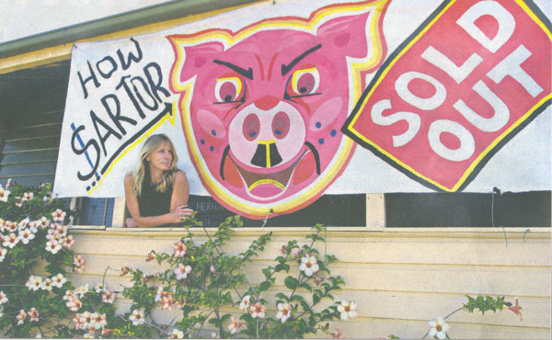

Get The Message: Catherine Hill Bay banner artist Margrete Erling makes clear her opposition to proposed developments in the village.

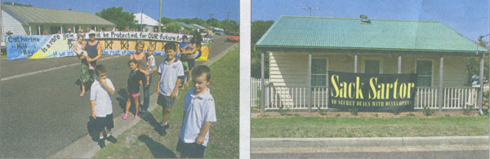

Frank Expression of Views: Catherine Hill Bay residents vent their anger at the proposed development and Planning Minister Frank Sartor.

